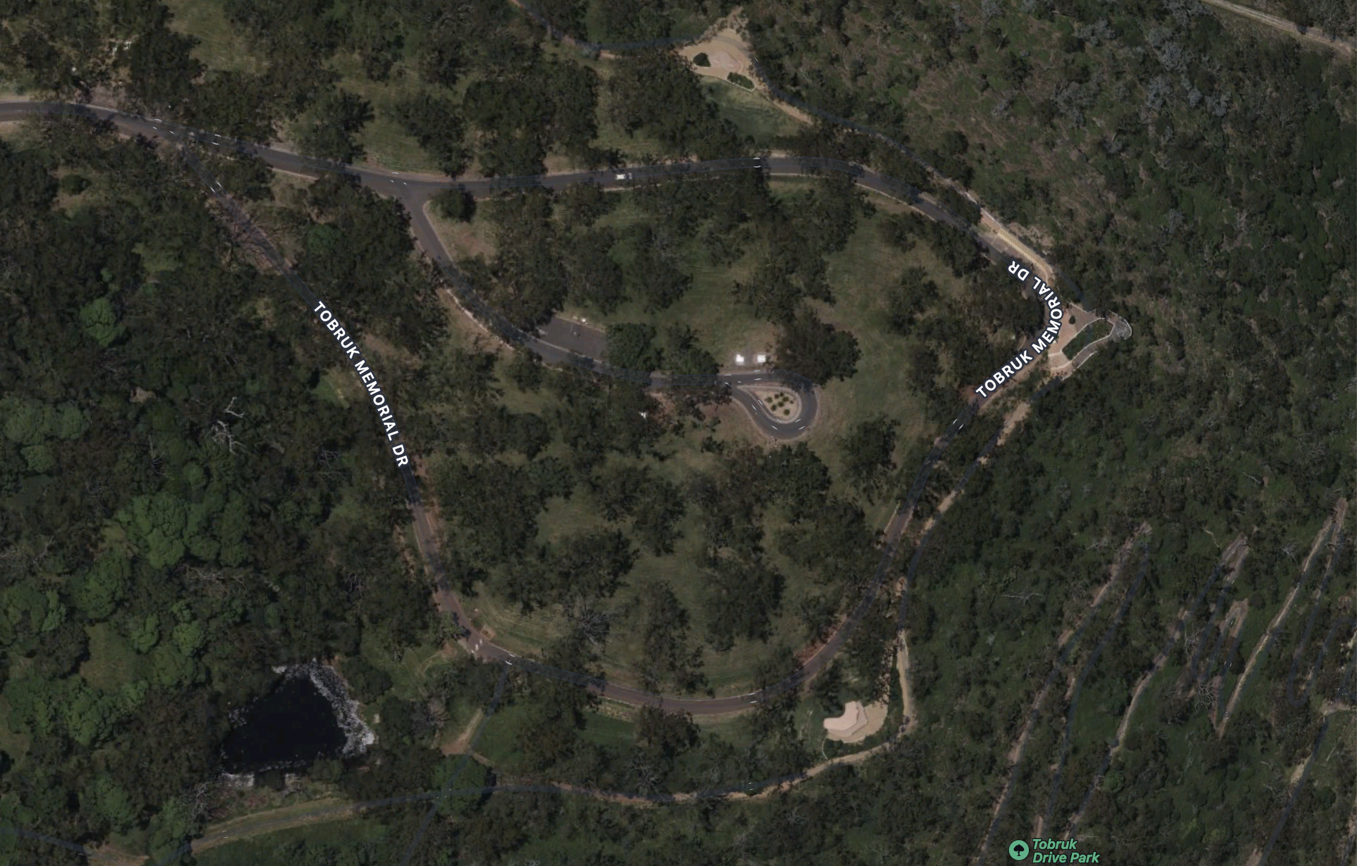

Parking up the hill on side of road

No Parking at the bottom of Tobruk Memorial DR – Drop Off Only

Disabled Drop Off

Books

Coffee

BBQ

Limited Parking

Main Commemoration Area